1. Click **Settings** SharePoint 2016 Settings button on title bar.  on the top right corner and then click **Site contents**.
2. Click **add an app**.

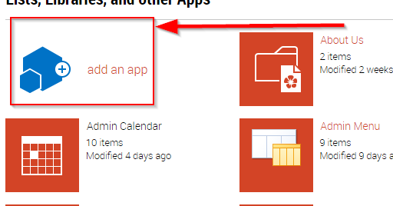

1. Click the **document library**.

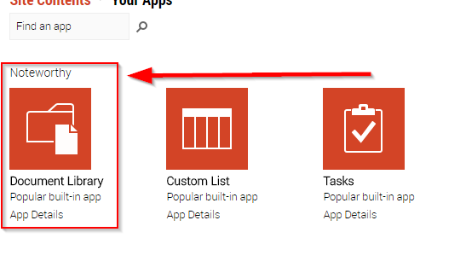

If you don't see the one you want, type a keyword into the search box and press search Search box magnifying glass icon .

1. Type a title into **Name** field.

You can also click **Advanced Options** and enter a **Description**.

1. Click **Create**.